**PROJECT REPORT**

on

**HOSPITAL MANAGEMENTSYSTEM**

Towards partial fulfillment of the requirement for the award of degree of

***Master of Computer Applications***

# From

**Babu Banarasi Das University**

**Lucknow**



**Academic Session 2020 - 2021**

**School of Computer Applications**

*SubmittedBy: Under Guidanceof:*

### Atul Kumar Shukla Mr. Kailash Joshi

|  |
| --- |
| **I Floor, H-Block, BBDU, BBD City, Faizabad Road, Lucknow (U. P.) INDIA 226028**  **PHONE: HEAD:** 0522-3911127, 3911321 **Dept. Adm. & Exam Cell:** 0522-3911326 **Dept. T&P Cell:** 0522-3911305; **E-Mail:** [head.sca@gmail.com](mailto:head.sca@gmail.com) |
| **w w w . b b d u . a c . i n** |

**Babu Banarasi Das University**

**Lucknow**

**CERTIFICATE**

#### This is to certify that Project Report entitled

**<HOSPITAL MANAGEMENT SYSTEM>**

**being submitted by**

<Atul Kumar Shukla>

**towards the partial fulfillment of the requirement for the award of the degree of**

**Master of Computer Applications**

# to

**Babu Banarasi Das University**

**Lucknow**

## in the Academic Year 2020-21

**is a record of the student’s own work carried out at**

<**OJD Computer Institute Pvt. Ltd.**>

**and to the best of our knowledge the work reported here in does not form a part of any other thesis or work on the basis of which degree or award was conferred on an earlier occasion to this or any other candidate.**

### Prabhash Ch. Pathak

#### HEAD (School of Computer Applications)

OJD COMPUTER

INSTITUTE PVT. LTD.

Date: 22/06/2021

**TO WHOM IT MAY CONCERN,**

This is to certify that Mr. Atul Kumar Shukla(LICA Final Semester) has successfullycompleted the project titled "Hospital Management System" as part of Internship program in our organization. He has done the project using Python &MySQLdatabase from February 2021 to day 2021.

We wish him all the best for a bright future.

OJD COMPUTER INSTITUTE PVT. LTD.

S-62, GOLE MARKET, MAHANAGAR, LUCKNOW - 226006

Mob: 99845 38899 | Email: [precursorlko@gmail.com](mailto:precursorlko@gmail.com)

Website: [www.precursorinfo.org](http://www.precursorinfo.org/)

## TABLE OF CONTENTS

|  |  |  |
| --- | --- | --- |
| **Chapter** | **Topic** | **Page No.** |
| **1** | **Introduction** | **9** |
| 1.1 | Purpose | 9 |
| 1.2 | Scope | 9 |
| 1.3 | Overview | 9 |
| **2** | **General Description** | **12** |
| 2.1 | Product Perspective | 12 |
| 2.2 | Product features | 12 |
| 2.3 | Design and Implementation Constraints | 12 |
| 2.4 | Assumption and dependencies | 13 |
| **3** | **Function Requirement** | **14** |
| 3.1 | Description | 14 |
| 3.2 | Technical issues | 15 |
| **4** | **Interface Requirements** | **16** |
| 4.1 | User Interface | 16 |
| 4.2 | Hardware Interface | 16 |
| 4.3 | Software Interface | 16 |
| 4.4 | Communication Interface | 16 |
| **5** | **Software requirement Analysis** | **17** |
| 5.1 | Define Problem | 17 |
| 5.2 | Define module & Functionality | 17 |
| **6** | **Software Design** | **18** |
| 6.1 | UML Diagram | 18 |
| 6.1.1 | State Diagram | 18 |
| 6.1.2 | Class Diagram | 21 |
| 6.1.3 | Use case Diagram | 22 |
| 6.1.4 | Sequence Diagram | 23 |
| 6.2 | Database Design | 24 |

|  |  |  |
| --- | --- | --- |
| 6.2.1 | E-R Diagram | 24 |
| **7** | **Non function Requirement** | **25** |
| 7.1 | Performance | 25 |
| 7.2 | Security | 25 |
| 7.3 | Reliability | 26 |
| 7.4 | Availability | 26 |
| 7.5 | Safety | 26 |
| 7.6 | Software Quality | 26 |
| 7.7 | Reusability | 26 |
| 7.8 | Maintainability | 26 |
| **8** | **Modules** |  |
| **9** | **Design Of Software** |  |
| **10** | ***HMS Methodologies*** |  |
| **11** | **Timeline Chart** | **27** |
| **12** | **Conclusion** | **28** |
| **13** | **References** | **29** |

1. **INTRODUCTION**

**Purpose:**

* The Software is for the automation of Hospital Management.
* It maintains two levels of users:
  + 1. Administrator Level
    2. User Level
* The Software includes Maintaining Patient details.
* Providing Prescription, Precautions and Diet advice.
* Providing and maintaining all kinds of tests for a patient.
* Billing and Report generation

### **Scope**

### The proposed software product is the Hospital Management System (HMS). The system will be used to get the Information from the patients and then storing that data for future usage.

### The current system in use is a paper-based system. It is too slow and cannot provide updated lists of patients within a reasonable time frame.

### The intentions of the system are to reduce over-time pay and increase the number of patients that can be treated accurately.

### Requirement statements in this document are both functional and non-functional.

### **Overview**

### This Software Requirements Specification (SRS) is the requirements work product that formally specifies Hospital Management System (HMS).It includes the results of both business analysis and systems analysis efforts various techniques were used to elicit the requirements and we have identified your needs, analyzed and refinedthem.

### The objective of this document therefore is to formally describe the system’s high-level requirements including functional requirements, non-functional requirements and business rules and constraints. The detail structure of this document is organized as follows:

### Section 2 of this document provides an overview of the business domain that the proposed **Hospital Management System (HMS)** will support.

### These include a general description of the product, user characteristics, general constraints, and any assumptions for this system.

### This model demonstrates the development team's understanding of the business domain and serves to maximize the team's ability to build a system that truly does support the business. Section 3 presents the detail requirements, which comprise the domain model.

|  |  |  |
| --- | --- | --- |
| Urine Test | X-Ray | Stool Test |
| Sonography Test | Gastroscopy Test | Colonoscopy Test |
| Blood Test | Biochemistry Test | Maintaining Patient’s Injection records |

## GENERALDESCRIPTION

### **Product Perspective:**

### This Hospital Management System is a self-contained system that manages activities of the hospital as Patient Info. Various stakeholders are involved in the hospital patient info system.

### **Product features:**

### The system functions can be described as follows:

### **Registration:**

### 

### When a patient is admitted, the front-desk staff checks to see if the patient is already registered with the hospital.

### If he is, his/her Personal Health Number (PHN) is entered into the computer. Otherwise, a new Personal Health Number is given to this patient.

### The patient’s information such as date of birth, address and telephone number is also entered into computer system.

### **Patient check out:**

### 

### If a patient checks out, the administrative staff shall delete his PHN from the system and the just evacuated bed is included in available-beds list.

### **Generation:**

### 

### The system generates reports based on the list of detailed information regarding the patient who has been admitted in the hospital

### **Design and ImplementationConstraints**

### **Database:**

### The system shall use the My SQL Database, which is open source and free.

### **Operating System**:

### The Development environment shall be Windows 2000.

### **Web-Based**:

### The system shall be a Web-based application.

### **Assumptions and Dependencies**

### It is assumed that one hundred IBM compatible computers will be available before the system is installed and tested.

### It is assumed that the Hospital will have enough trained staff to take care of the system.

## FUNCTIONALREQUIREMENTS

**Description Registration:**

#### Add patients:

#### The HMS shall allow front-desk staff to add new patients to thesystem.

#### Assign ID:

#### The HMS shall allow front-desk staff to give each patient an ID and add it tothe patient’s record. This ID shall be used by the patient throughout his/her stay in hospital.

#### Delete Patient ID:

#### The administrative staff in the ward shall be allowed to delete the ID of thepatient from the system when the patient checksout.

#### Add to beds-available list:

#### The administrative staff in the ward shall be allowed to put the beds just evacuated in beds- available list.

### **Report Generation**

#### Patient information:

#### The HPIMS shall generate reports on patients about the followinginformation: Patient’s PHN, Patient’s name, Ward name, Bed number and the doctor’s name which was assigned.

#### Bed Availability:

#### The HPIMS shall generate reports on bed availability about thefollowing information: ward name, bed number, occupied /unoccupied.

### **Database**

#### Patient MandatoryInformation:

#### Each patient shall have the following mandatory information: first name, last name, phone number, personal health number, address, postal code, city, country, patient identification number.

#### Update PatientInformation:

#### The HPIMS shall allow the user to update any of the patient’s information as described in SRS007.

### **Technical issues**

#### Database:

#### The system shall use the MySQL Database, which is open source and free.

#### OperatingSystem:

#### The Development environment shall be Windows 2000.

#### Web-Based:

#### The system shall be a Web-based application.

## INTERFACE REQUIREMENTS

### **UserInterface:**

### The software provides good graphical interface for the user any administrator canoperate on the system, performing the required task such as create, update, viewing the details of the book.

### Allows user to view quick reports like Book Issues/Returned etc. in betweenparticular time.

### Stock verification and search facility based on differentcriteria.

### **HardwareInterface:**

* Operating system:window
* Hard disk :40GB
* RAM: 256 MB
* Processor: Pentium(R)Dual-coreCPU

### **Software Interface:**

* MS SQL server2005
* Python 3.8

### **CommunicationInterface:**

* Window

## SOFTWARE REQUIREMENTANALYSIS

### **DefineProblem:**

### We develop the hospital management system for the hospital staff and other department thatfor record for all the user.

### **Define module &Functionality:**

The system functions can be described as follows:

1. **Registration:** When a patient is admitted, the front-desk staff checks to see if the patient is already registered with the hospital. If he is, his/her Personal Health Number (PHN) is entered into the computer. OTHERWISE, a new Personal Health Number is given to this patient. The patient’s information such as date of birth, address and telephone number is also entered into computer system.
2. **Patient check out:** If a patient checks out, the administrative staff shall delete his PHN from the system and the just evacuated bed is included in available-beds list.
3. **SOFTWAREDESIGN**

### **UMLDIAGRAM**

#### STATEDIAGRAMS

### 

Figure 1:State Diagram for Doctor Object

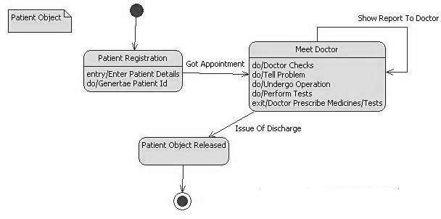

Figure 2:State Diagram for Patient Object

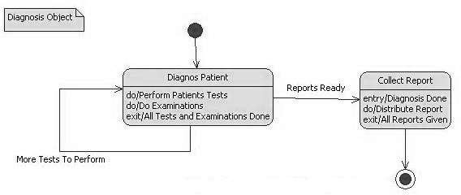

Figure 3:State Diagram for Diagnosis Object

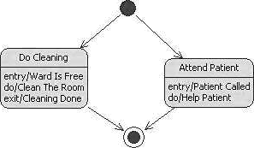

Figure 4:State Diagram for Ward Object

### **CLASS DIAGRAM**

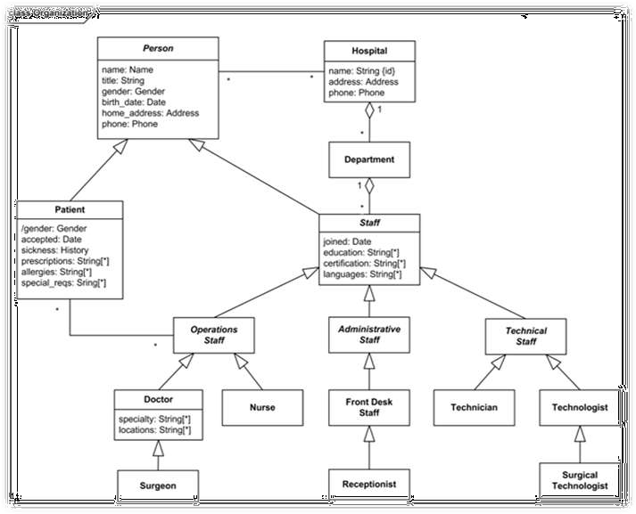

Figure 5

1. 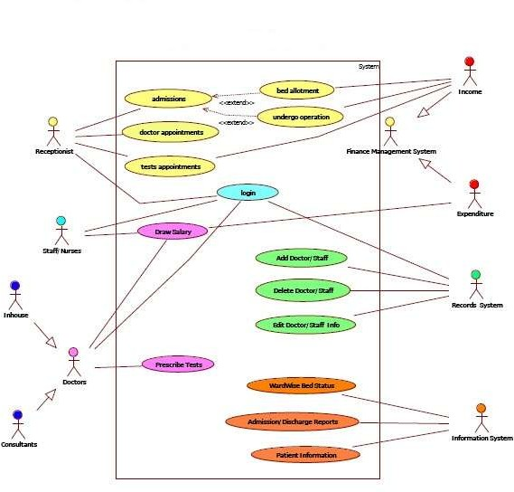**USE CASEDIAGRAM**

Figure 6

1. 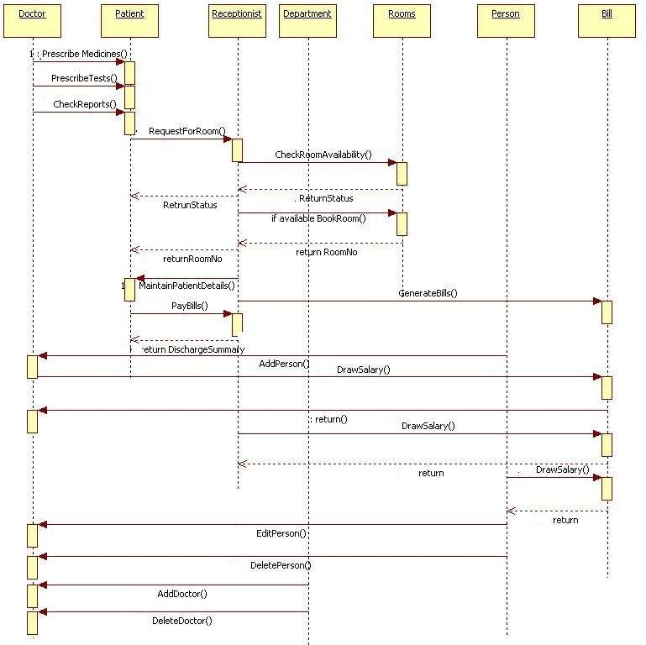**SEQUENCEDIAGRAM**

Figure 7

1. 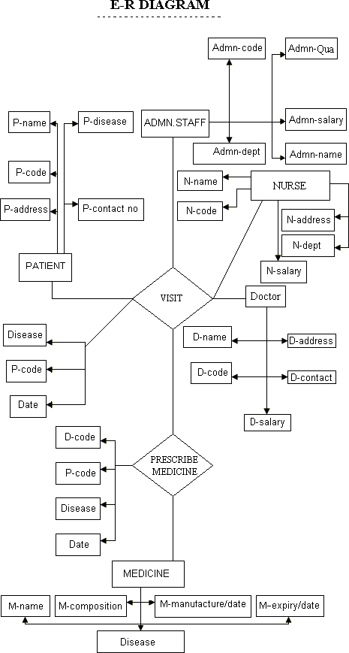**DATABASEDESIGN**

Figure 8: ER Database

1. **NON- FUNCTIONALREQUIREMENT**
2. **Performance**
   * **Response Time:** The system shall give responses in 1 second after checking the patient’s information.
   * **Capacity:** The System must support 1000 people at a time.
   * **User-interface:** The user-interface screen shall respond within 5 seconds.
   * **Conformity:** The systems must conform to the Microsoft Accessibility

### **Security**

#### Patient Identification: The system requires the patient to identify himself /herself using PHN

#### Login ID: Any user who uses the system shall have a Login ID and Password.

#### Modification: Any modification (inert, delete, update) for the Database shall be synchronized and only by the administrator in the ward.

#### Front Desk staff Rights: Front Desk staff shall be able to view all information in HPIMS, add new patients to HPIMS but shall not be able to modify any information in it.

#### Administrators 'Rights: Administrators shall be able to view and modify all information in HPIMS.

### **Reliability**

### How general the form generation language is Simplicity Vs. Functionality of the form language speeds up form development but does not limit functional.

### **Availability**

### The system shall be available all the time.

### **Safety**

### Humans are error-prone, but the negative effects of common errors should be limited. E.g., users should realize that a given command will delete data, and be asked to confirm their intent or have the option to undo.

### **Software Quality**

### Good quality of the framework produces robust, bug free software which contains all necessary requirements Customer satisfaction.

### **Reusability**

### It is part of the code going to be used elsewhere = produces simple and independent code modules that can be reused

### **Maintainability**

#### Back Up: The system shall provide the capability to back-up the Data.

#### Errors: The system shall keep a log of all the errors.

1. **MODULES**

### **Patient Management System:**

### Hospital Management System developed by Solution Dots Systems provides complete assistance in patient management. In the module of the patient management system, there is a facility to register patients and view their reports and history. Patient management system allows getting detail information of patient’s health condition.

### **Doctor Management System:**

Doctor Management System allows registering the doctors, working in a hospital as well as their clinic details. It helps in the duty management of doctors and updates them complete appointment details with a patient health history.

### **Drugs Management System:**

Drugs Management System is another module of hospital Management System developed by Solution Dots Systems and allows to add the list of drugs mostly use for the purpose of treatment in that specific hospital. The drugs used in the treatment of some specific patient could also enlist here. The list of available drugs is also managed in this drug management system.

1. **Administrative Rights Management System:**

Administrative Rights Management System includes all right of management including HR and administration. This payroll system helps in updating the inventory record as well as all record of payroll management. This is a key element of administration management that manages all purchases and employee management.

### **Online Appointment Management System:**

Online Appointment Management System allows getting online appointment instead of physical visit. With the help of online appointment management system patient, staff and doctor can check the status of appointment easily. This appointment management system allows to get an appointment for registered patients and also send updates to the customer through SMS or email.

### **Invoice System:**

After the appointment confirmation Invoice System generates an automatic invoice against that specific patient, this invoice helps to know about the current status of payment as well as complete payment.

### **Medical Services System:**

Medical Services System allows adding a list of services that are provided by the hospital such as dental treatment service, cardiac services, mental treatment services, bones treatment services and much more. The patient is able to view the list of services and departments offered by the hospital along with all other details of treatment. It also manages the service timing, emergency services according to the condition of the patient.

### **Doctor Services Report System:**

Doctor Services Report System allows getting complete information and management about the services of doctors. In this report details of doctors such as their specialization field, their work efficiency, and their duty hours and many other details and information could be managed by the management.

### **Lab Test System:**

Lab Test System carry complete details of the test services that are available in the hospital such as X-ray, CBC test, and blood test and different other test services. It also manages the history of test details according to the registered patient name.

1. **DESIGN OF SOFTWARE**
2. **General Home Page**

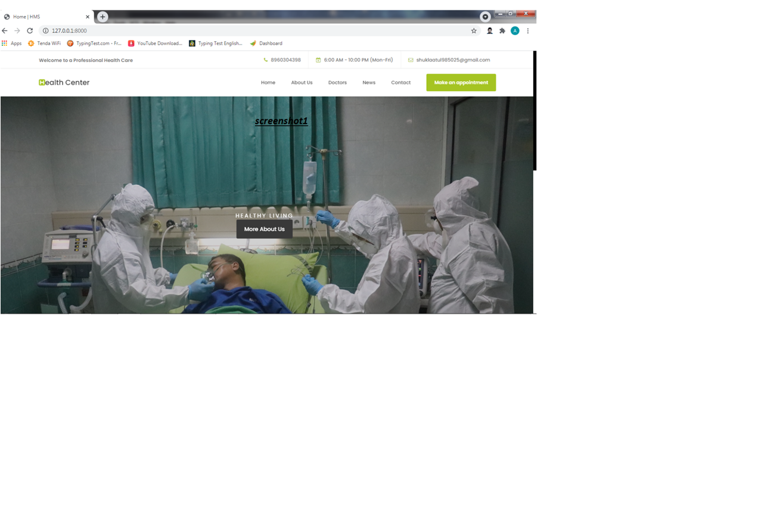

1. **About Us Page**

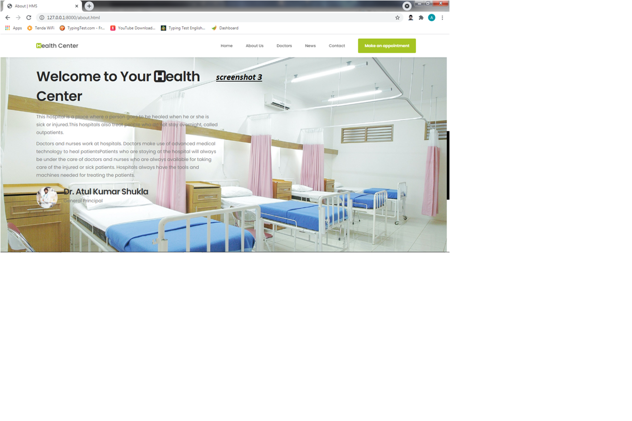

1. **Doctor’s Page**

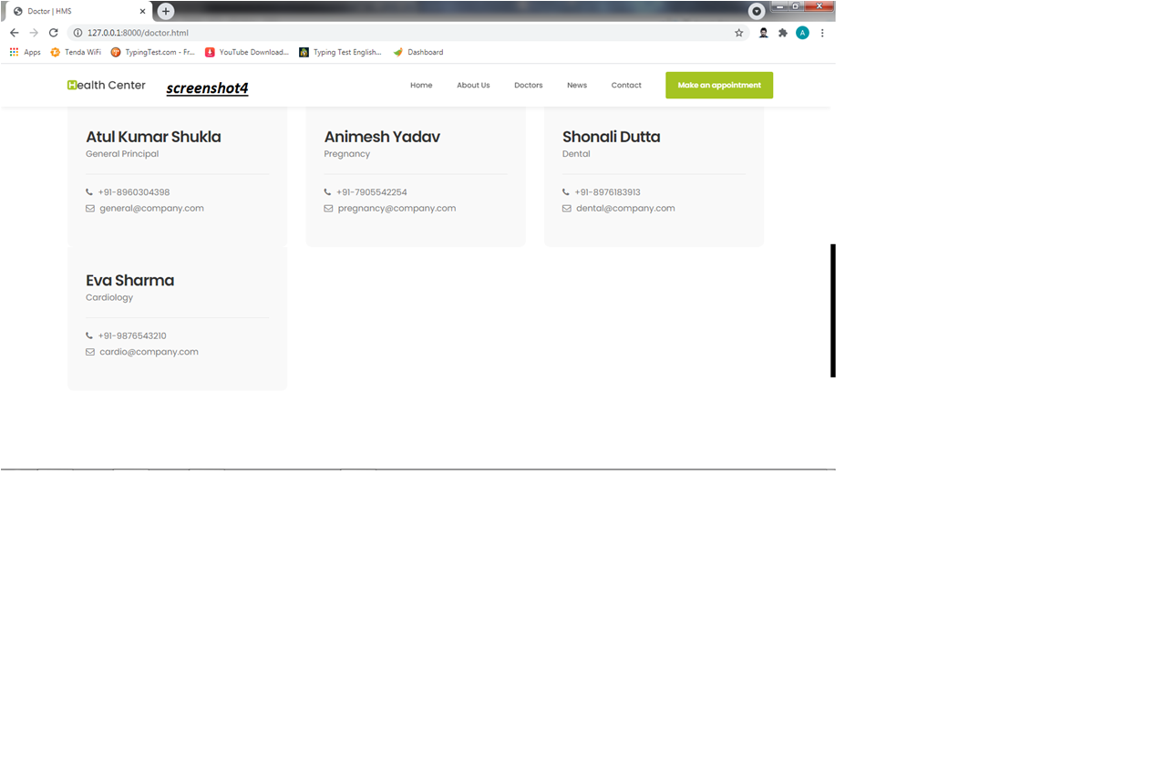

1. **Footer page**

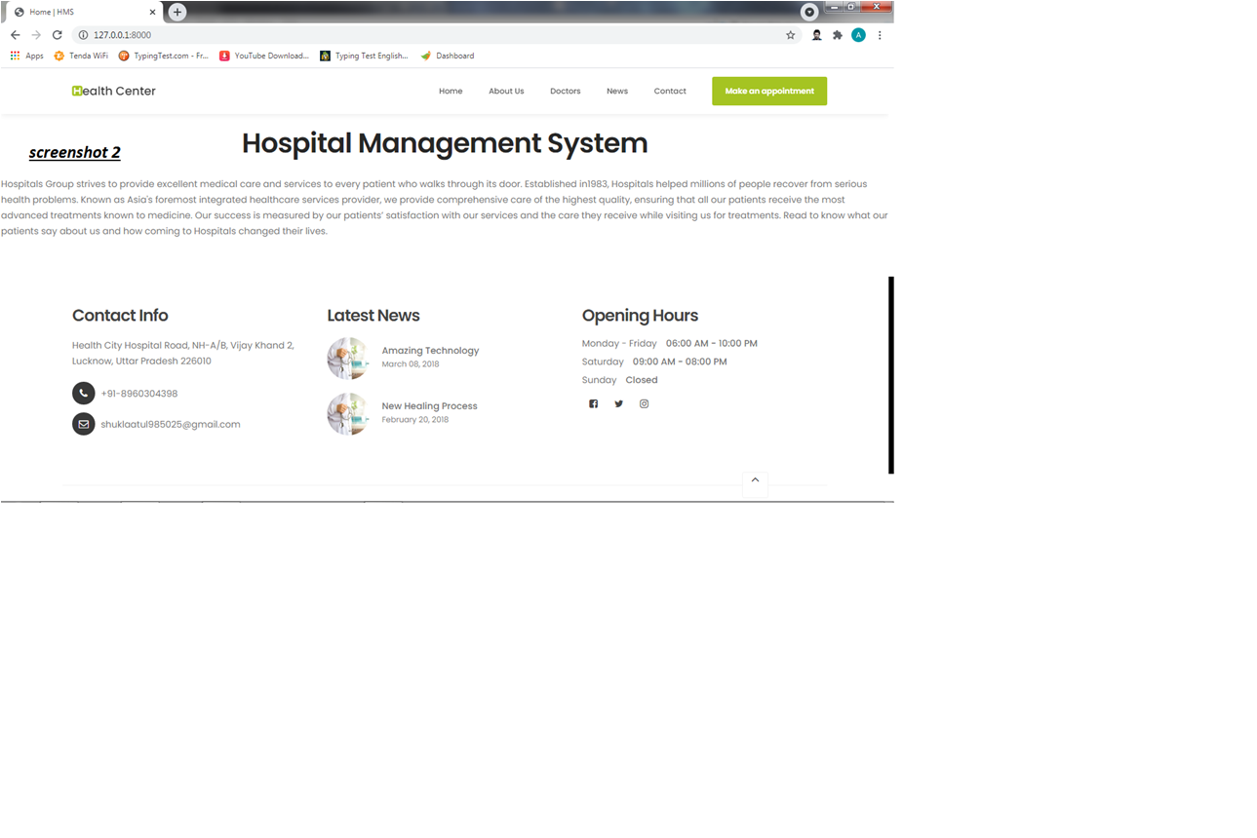

1. **Appointment Page**

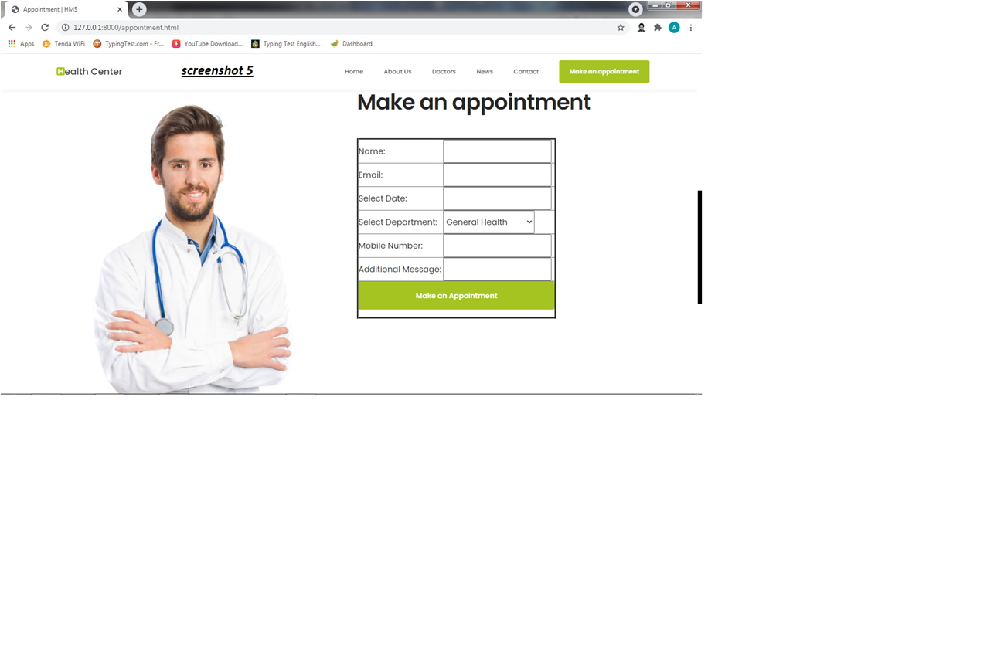

**6.Xampp server**

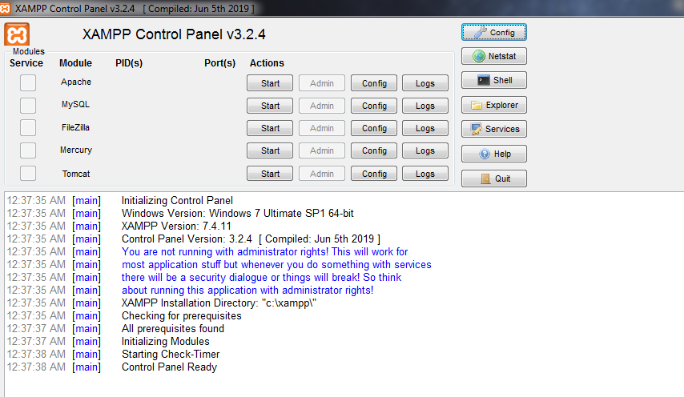

**7.Server On**

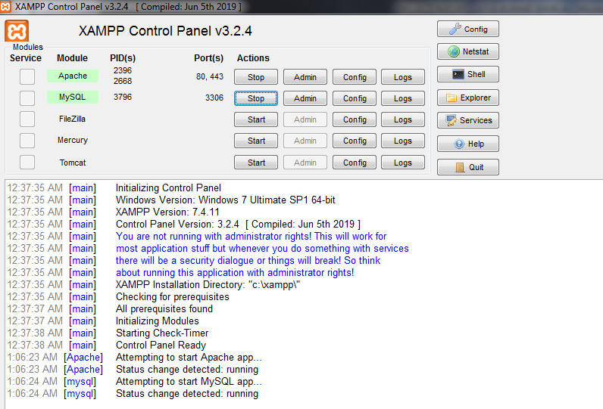

**8.Pycharm**

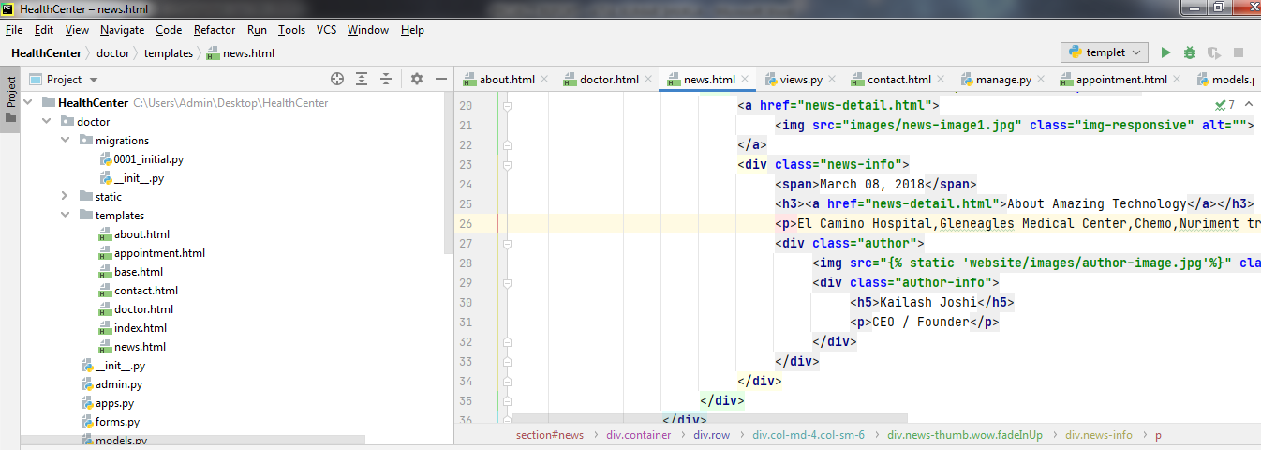

**9.Coding For About Us Page**

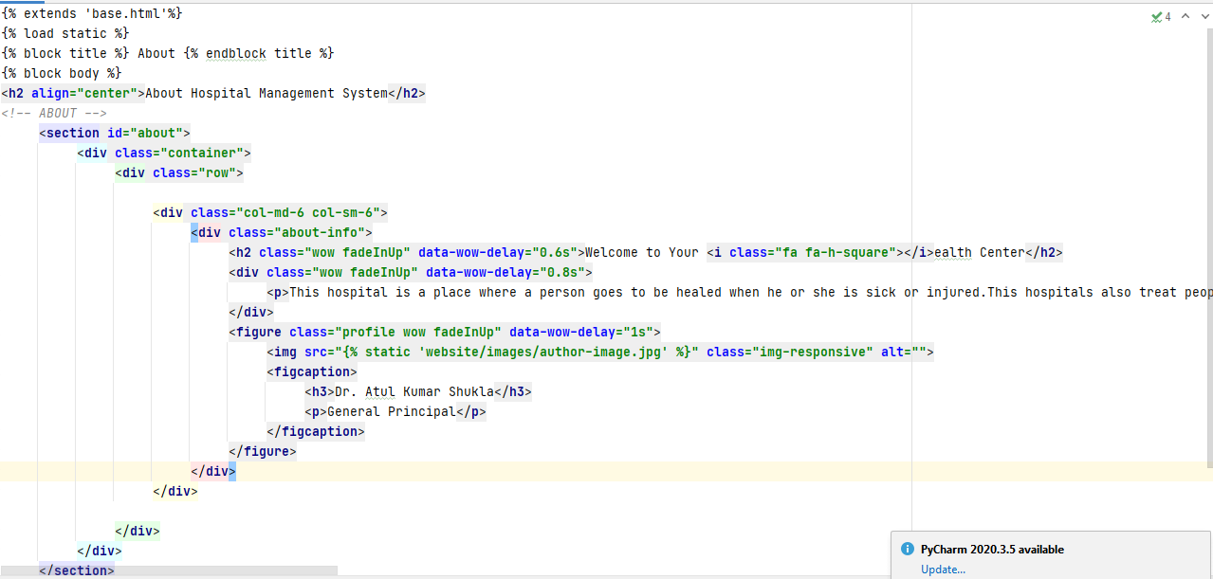

**10.Coding For Doctor’s Page**

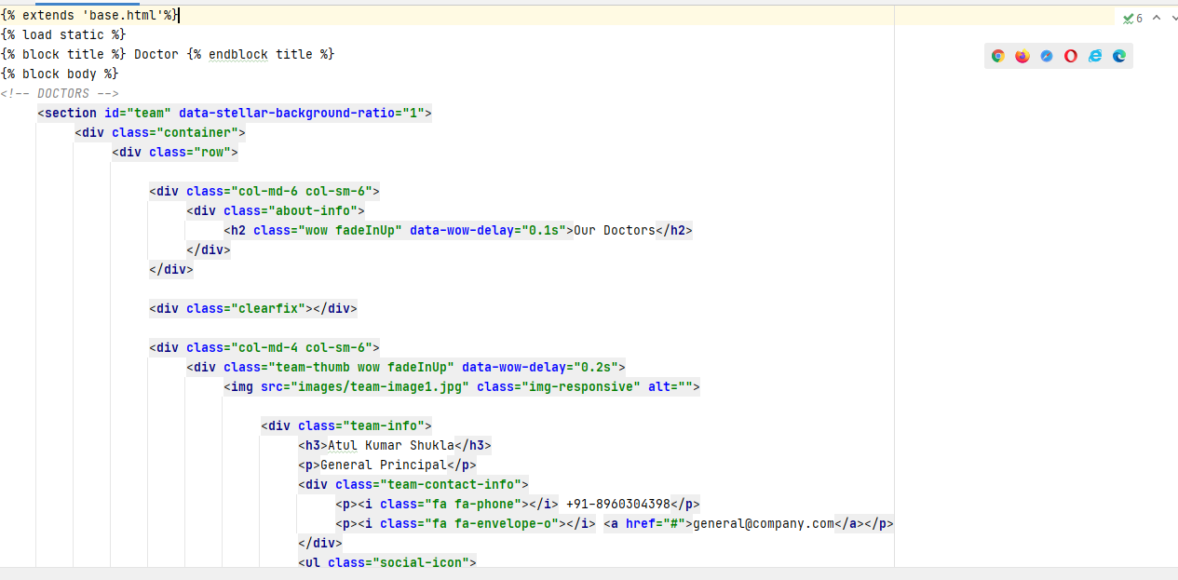

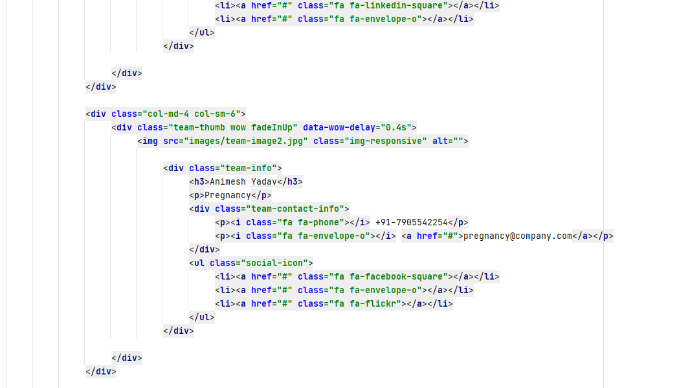

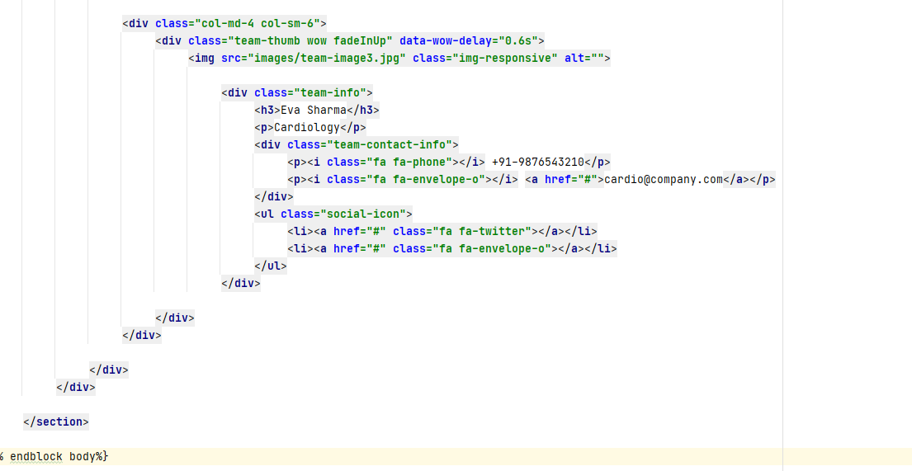

1. **Coding For News Page**

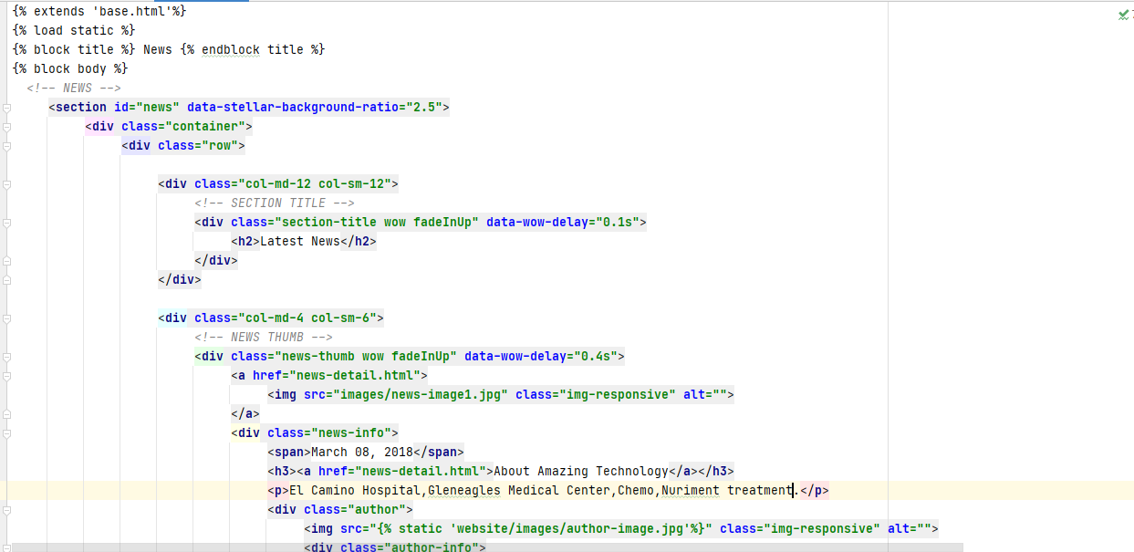

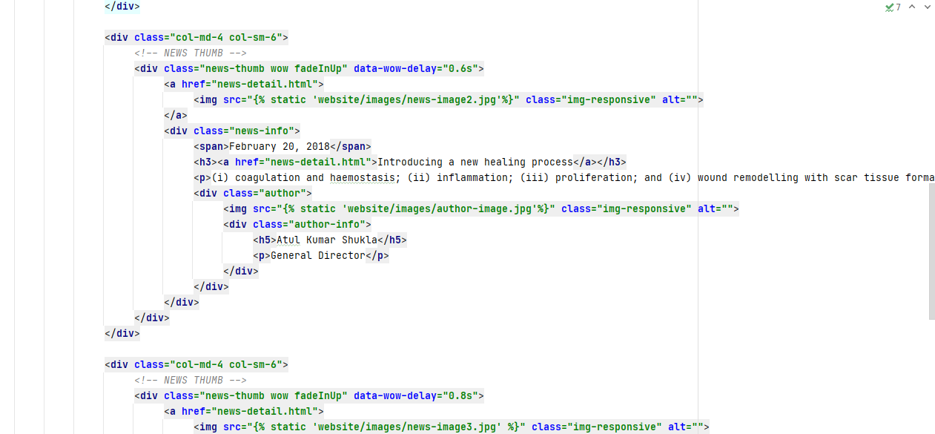

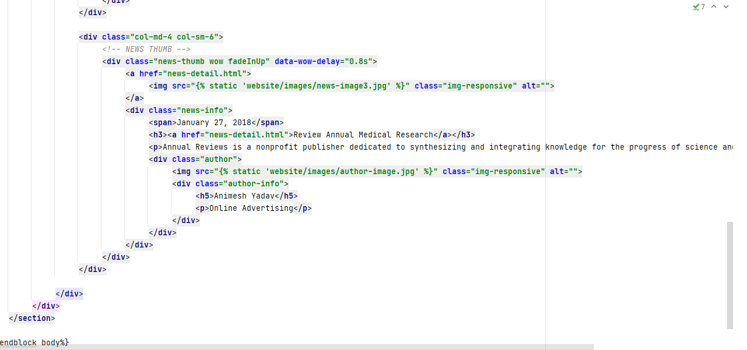

**12.Coding For Views.py Page**

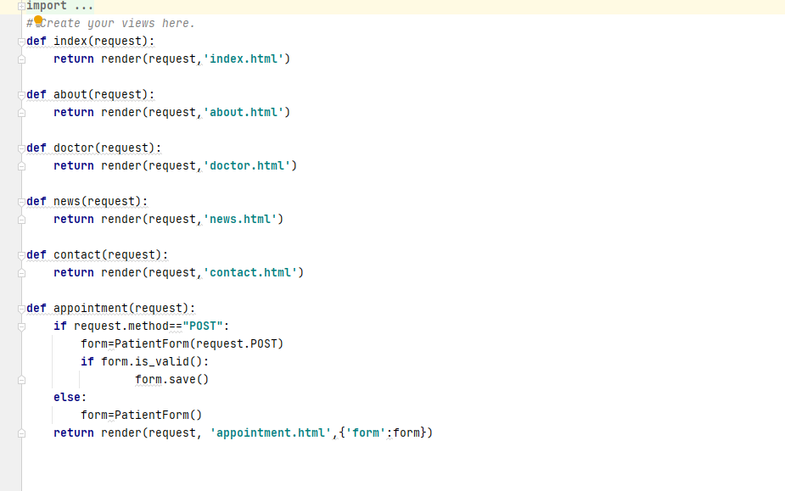

**13.Coding For Contact Page**

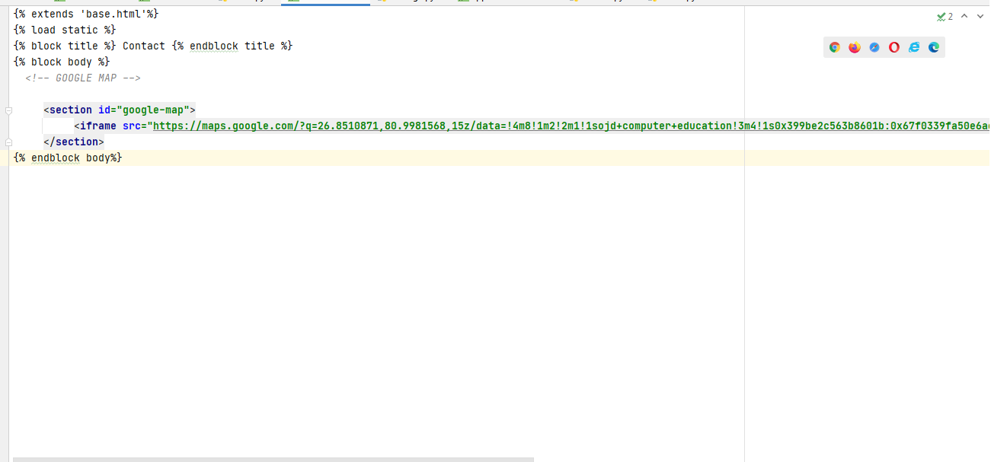

**14.Coding For Manage.py Page**

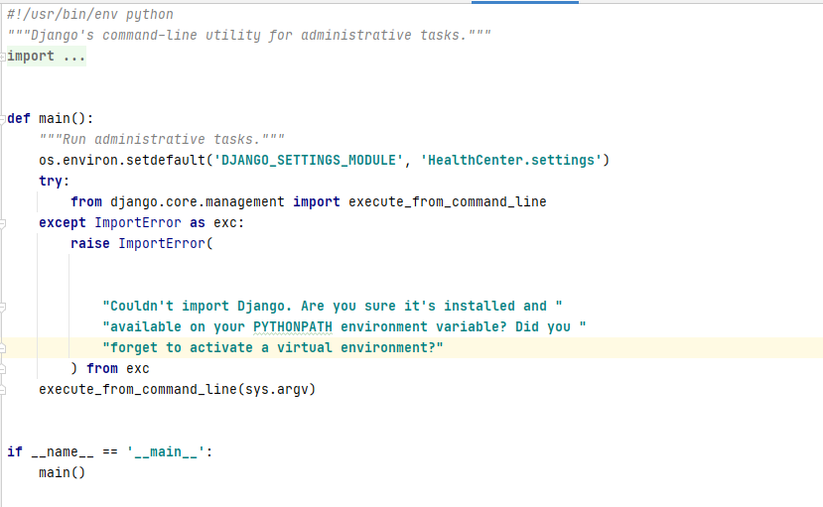

**15.Coding For Appointment Page**

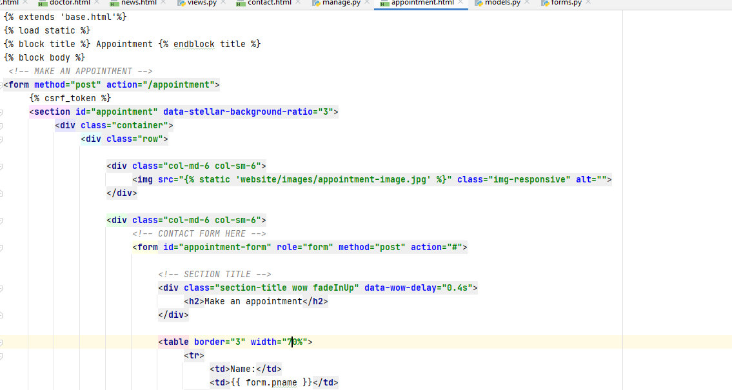

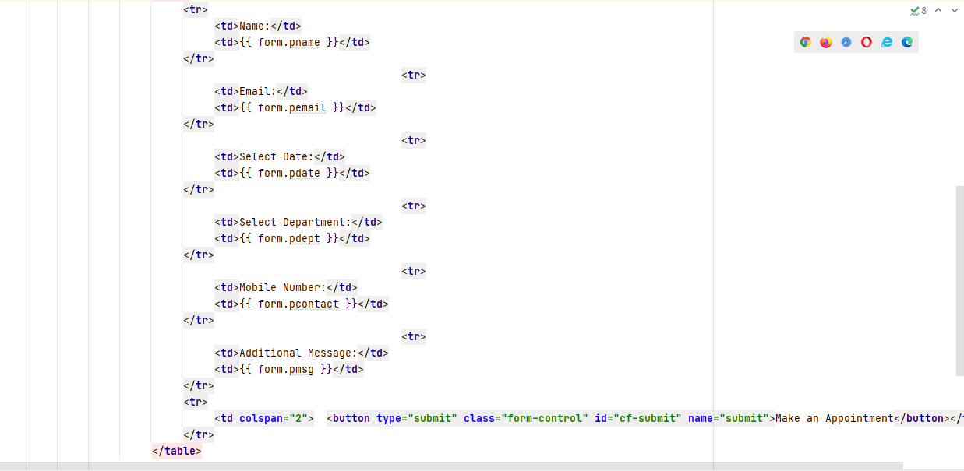

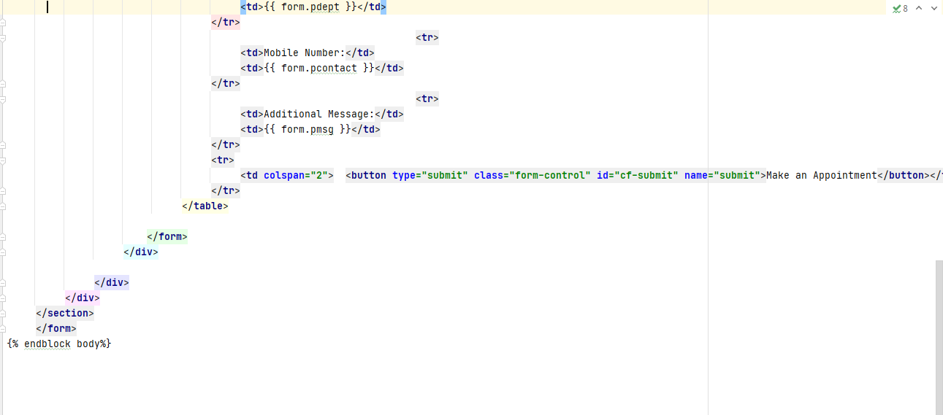

**16.Coding For Models.py**

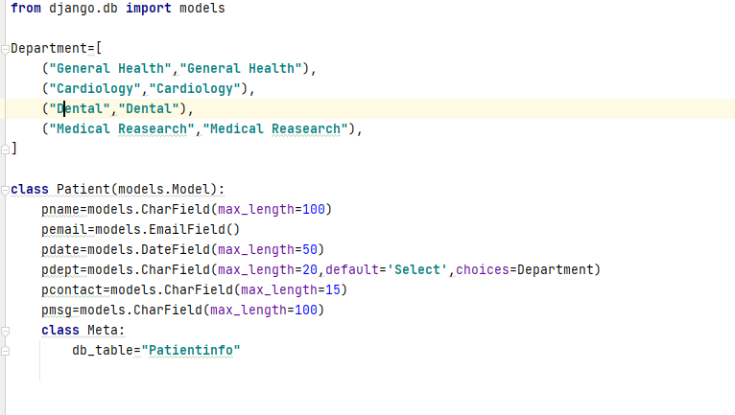

**17.Coding For Forms.py**

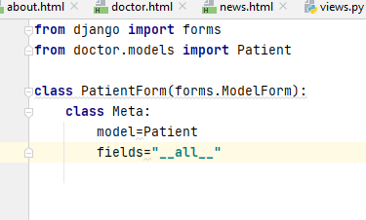

1. **HMS METHODOLOGIES**

* We offer specialized HMS services that help reduce costs and time of patient through managed and automated online services.
* The hospital management system (HMS) is an integrated software that handles different directions of clinic workflows.
* It manages the smooth healthcare performance along with administrative, medical, legal and financial control.
* That is a cornerstone for the successful operation of the healthcare facility**.**

## 11.TIMELINE CHART

Figure 9

**12.CONCLUSION**

The project Hospital Management System (HMS) is for computerizing the working in a hospital. The software takes care of all the requirements of an average hospital and is capable to provide easy and effective storage of information related to patients that come up to the hospital. It generates test reports; provide prescription details including various tests, diet advice, and medicines prescribed to patient and doctor. It also provides injection details and billing facility on the basis of patient’s status whether it is an indoor or outdoor patient. The system also provides the facility of backup as per the requirement. This SRS document is used to give details regarding Hospital Patient Info Management System. In this all the functional and non-functional requirements are specified in order to get a clear-cut idea to develop a project.

## 13.REFERENCES

1. [www.google.com](http://www.google.com/)
2. [www.diagram.ly](http://www.diagram.ly/)
3. [www.umldiagram.org](http://www.umldiagram.org/)